HackerRank - For Loop in C
Code:
#include <stdio.h>

int main() {
int a, b;
scanf("%d", &a);
scanf("%d", &b);
for (int i = a; i <= b; i++) {
if (i == 1) {
printf("one\n");
} else if (i == 2) {
printf("two\n");
} else if (i == 3) {
printf("three\n");
} else if (i == 4) {
printf("four\n");
} else if (i == 5) {
printf("five\n");
} else if (i == 6) {
printf("six\n");
} else if (i == 7) {
printf("seven\n");
} else if (i == 8) {
printf("eight\n");
} else if (i == 9) {
printf("nine\n");
} else if (i % 2 == 0) {
printf("even\n");
} else {
printf("odd\n");
}
}
return 0;
}

Screenshot:

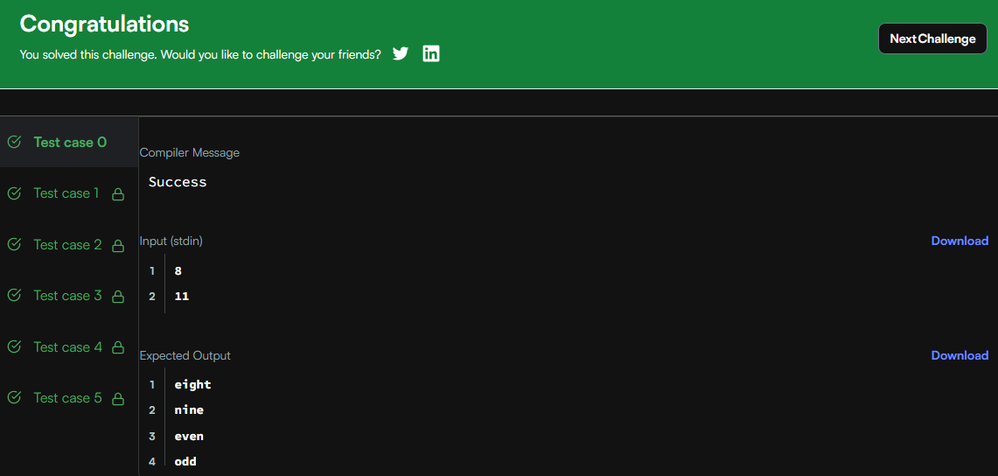

Link:
https://www.hackerrank.com/challenges/for-loop-in-c/problem

